Technical Proposal
Now Health International – Headless Multi-Region Website Platform

Prepared by: Riseup Labs
Date: February 06, 2026

1. Introduction
This document provides a technical proposal to develop a modern, enterprise-grade headless website platform for Now Health International using a shared codebase, CMS, and region-specific content control. The solution will be developed from scratch and optimized for performance, SEO, multilingual delivery, and secure lead capture workflows.
Key constraints for this proposal:
- Scope is limited to development (frontend, backend/CMS, database, integrations, DevOps, QA).
- Design and UI/UX are out of scope. Implementation will follow client-provided design assets and UI specifications.
- Third-party licensing/usage fees (hosting, CRM, analytics, CDN/WAF, test services, etc.) are excluded and will be billed directly to the client.
- Any requirements beyond the agreed scope will be handled through a Change Request (CR) process.

2. Project Context & Objectives
Now Health International provides international private medical insurance for individuals, families, corporates, brokers, and medical providers. The objective of this project is to deliver a scalable web platform that supports unified branding with per-region content autonomy, multilingual delivery (English + Chinese), conversion-focused lead capture, and secure content operations.

2.1 Target Websites
Website | Primary Language(s) | Purpose
Now Health International | English | Global marketing, plan discovery, and lead acquisition
WorldCare International | English | Insurance products + provider network directory
Now Health International (China) | English + Chinese | China-specific offering and provider access with localization
All websites will share a unified design system, shared codebase, CMS architecture, and independent content control per region/locale.

3. Proposed Technical Approach & Methodology
We propose a headless, component-driven architecture where the frontend applications (Next.js) consume content and configuration from Strapi CMS via secure APIs. This approach enables high SEO performance (SSR/SSG), rapid content iteration, multi-brand theming per website, and consistent engineering standards across all regions.

3.1 Delivery Methodology
- Delivery with acceptance checkpoints.
- Definition of Done per feature: requirements confirmed, implemented, tested, documented, and deployed to staging.
- API contract-first development.
- Security-by-design: RBAC for CMS/admin, audit logging, secure secrets handling, and OWASP-aligned practices.
- Performance-first: SSR/SSG strategy, caching, CDN asset delivery, and Lighthouse-targeted optimization.

3.2 Environments & Governance
- Environments: Local → Staging → Production (separate configs and secrets).
- Source control: GitHub/GitLab with PR-based code reviews.
- CI/CD: automated build, lint, test, and deployment pipelines.
- Release governance: sign-off on staging prior to production release.

4. Proposed Technical Stack
Layer | Proposed Choice (Aligned with Scope Document)
Frontend Framework | React /Next.js
Language | TypeScript
Styling | Tailwind CSS
State Management | React Context; Zustand only if required
Component Documentation | Storybook (recommended)
Headless CMS | Strapi (Node.js runtime)
API | REST (primary)
Database | PostgreSQL (preferred)
Caching (optional) | Redis for caching and rate-limit counters
Hosting | Frontend: AWS; CMS: AWS or Managed VPS
Containerization | Docker (recommended)
Observability | Centralized logging + APM + error tracking (provider-based)
Security | TLS/SSL, WAF (recommended), input sanitization, rate limiting, audit logs

5. Scope of Work (Development Only)
This scope is divided into two (2) workstreams for clarity: Frontend and Backend/CMS.

5.1 Frontend Scope (Web Apps – Next.js)
Frontend development includes building responsive, SEO-optimized web applications for the three websites using a shared component library and theming.

5.1.1 Core Frontend Capabilities
- Responsive behavior: Mobile-first, tablet optimized, desktop optimized; cross-browser/device testing support.
- Design system implementation: grid, typography, tokens, shared icon library, spacing system, multi-brand themes.
- Shared UI components: header/mega menu, footer, CTA blocks, cards, tabs, forms, modals, alerts.
- SEO & performance: SSR/SSG strategy, metadata, optimized images/assets via CDN, Lighthouse-targeted optimization.
- Accessibility: WCAG 2.1 AA aligned implementation for navigation, forms, and content blocks.

5.1.2 Page-Level Build (Representative)
Pages will be implemented as per the scope document, including (but not limited to):
- Now Health International: Homepage, Plans overview, Plan detail pages, Country pages, Who We Help, Blog listing/detail, Expat guides, Testimonials, How to Claim, How to Use Your Plan, Find a Medical Provider, Contact, About, FAQs, Legal pages.
- WorldCare International: Homepage, Insurance pages, Product listing/detail, Medical network directory, Download center, Member area (login CTA), About, Contact, News/Articles, FAQs, Why Choose Us, Legal pages.
- Now Health China: Homepage, Plan pages, Network/Provider pages, About, Contact, Member pages, FAQs, Download center, Legal pages (bilingual EN/中文).

5.1.3 Frontend HR & Responsibilities
Role | Key Responsibilities
Project Manager | Backlog, acceptance criteria, planning, stakeholder coordination
Frontend Tech Lead | Architecture, component standards, SSR/SSG strategy, code reviews
Web Frontend Engineer(s) | Component/page development, API integration, SEO/performance
QA Engineer | UI regression, cross-device/browser verification
DevOps | Frontend deployments, environment configuration, monitoring baseline

5.2 Backend & CMS Scope (Strapi + APIs + DB)
Backend scope covers Strapi CMS configuration, content models, API layer, database, media library, RBAC, audit logging, and CRM/lead capture integrations.

5.2.1 CMS (Strapi) Configuration
- Content models: Pages, Insurance Products, Plans & Coverage, Countries/Regions, Blogs/Articles, FAQs, Testimonials, Careers, Downloads, SEO metadata.
- Localization: English (all sites), Chinese (China site) with localized SEO fields and independent per-locale content.
- Media management: centralized library, folder structure per website, optimized image delivery and secure asset handling.
- Publishing workflow: draft/review/publish using roles (Admin, Editor, Reviewer).

5.2.2 Lead Capture & CRM Workflow
- Input channels: Get a Quote (multi-step), Contact forms, Broker/Corporate inquiry, Provider applications, Download requests, Member support, Chinese-language forms.
- API layer: data sanitization and enrichment, field mapping (website → CRM), secure submission, retry queue + logs for failure handling.
- Routing: region-based lead routing rules and reporting-ready submission logs.

5.2.3 Performance & Security Controls
- SSL/TLS enforced; HSTS recommended; secure headers baseline.
- Input sanitization, rate limiting, and anti-spam controls for public forms.
- PII handling: store only agreed marketing/contact data; avoid storing sensitive medical data in the website platform.
- RBAC + audit logs for admin actions (content edits, publish actions, role changes).
- Monitoring: API logs, error tracking, and alerting for availability.

5.2.4 Backend HR & Responsibilities
Role | Key Responsibilities
Tech Lead | Architecture, API standards, security controls, integration design
Backend Engineer(s) | Strapi setup, custom APIs, DB schema/migrations, CRM integration
DevOps Engineer | Infra, CI/CD, environments, secrets, backups, monitoring
QA Engineer | API/integration testing, security checklist verification
PM | Requirements validation, CRM mapping, acceptance and sign-off management

6. Deliverables
- Three production-ready websites built on a shared Next.js codebase with theme support.
- Strapi CMS configured with content models, localization, roles/workflows, and media management.
- API documentation (OpenAPI), CMS admin guide, and technical runbook for operations.
- CI/CD pipelines, staging & production deployments, monitoring/logging baseline.
- QA artifacts: test plan, test cases, bug reports, regression checklist, and release readiness checklist.
- Handover session and code walkthrough with client technical stakeholders.

7. Technical Diagrams
Insert images in the spaces below in the final version:

Diagram 1: High-Level Solution Architecture
Next.js Web Apps → Strapi/API Layer → PostgreSQL + Media Storage → CRM → Observability/Audit]
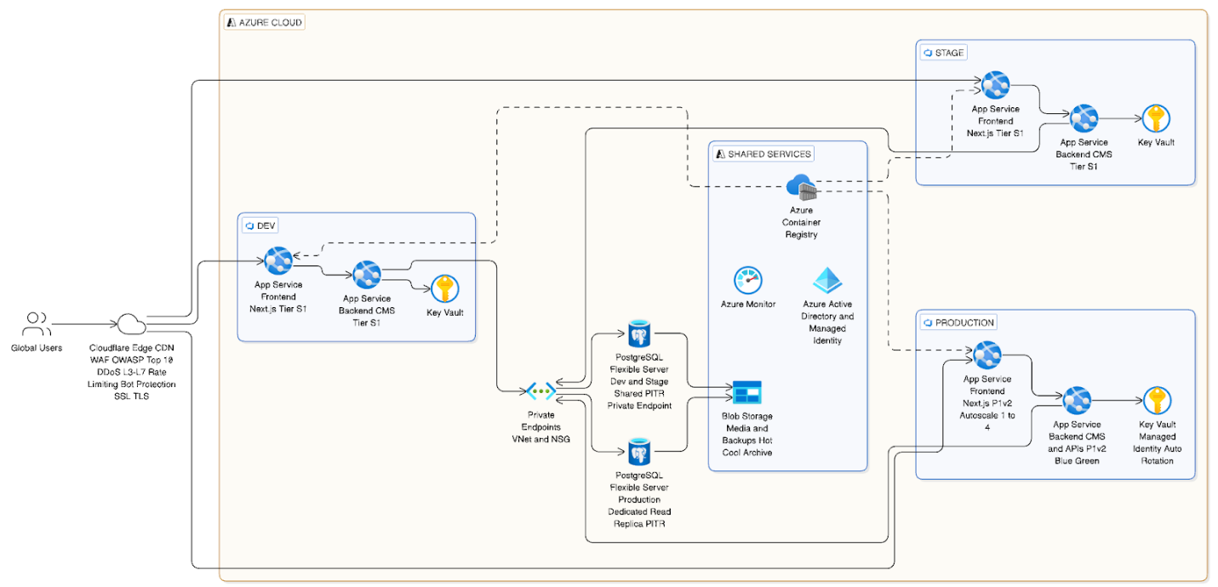

Diagram 2: Lead Capture & CRM Routing Flow
Web Form → Validation → API → Mapping → CRM → Retry Queue/Logs → Regional Routing

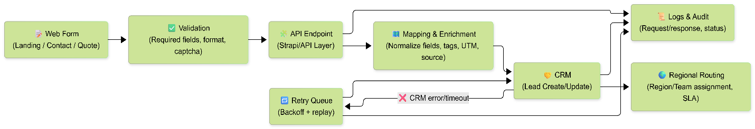

Diagram 3: CI/CD Strategy
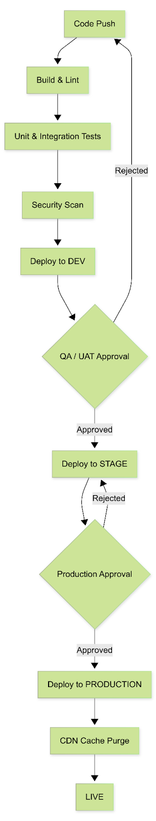

8. Complimentary Support (1 Month)
After production launch and final handover, we will provide one (1) month of complimentary support focused on the delivered scope.
Included:
- Bug fixing for reproducible issues introduced by the delivered work.
- Minor adjustments within existing UI patterns (small layout/copy/config changes).
- Support for analyzing logs and error reports where access is provided.
Excluded:
- New features or major enhancements beyond the agreed scope.
- Changes due to third-party provider policy changes or credential delays.
- Fixing pre-existing issues unrelated to the delivered modules.

9. Timeline

Scope | Scope of Work | Timeline
Backend | Backend & CMS Scope (Strapi + APIs + DB) | 5 Weeks
Frontend | Frontend Scope (Web Apps – Next.js)

9.1 Assumptions & Remarks
- Client will provide final UI designs and brand guidelines before frontend implementation starts for each website.
- Client will confirm CRM provider and provide necessary API credentials and field mapping requirements.
- Content entry and final proofreading are owned by the client; our scope includes CMS setup and support for migration templates.
- Timelines may shift if third-party credentials, DNS/domain changes, or compliance approvals are delayed.
- Any additional requirements beyond this scope will be treated as Change Requests.

10. Proposed Out of Scope
- UI/UX design, visual redesign work, branding, and creation of design assets (Figma, interaction design).
- Medical claims processing systems or storage of sensitive medical records within the website platform.
- Ongoing content production (blog writing), translation services, or ongoing SEO content strategy.
- Third-party subscription fees (hosting, CRM, analytics, WAF, testing services).

11. Acceptance & Sign-off
Delivery will be considered accepted when the agreed scope is implemented on staging, passes the QA and regression checklist, and is formally signed off by the client. Production deployment will proceed after sign-off and completion of the release checklist.

